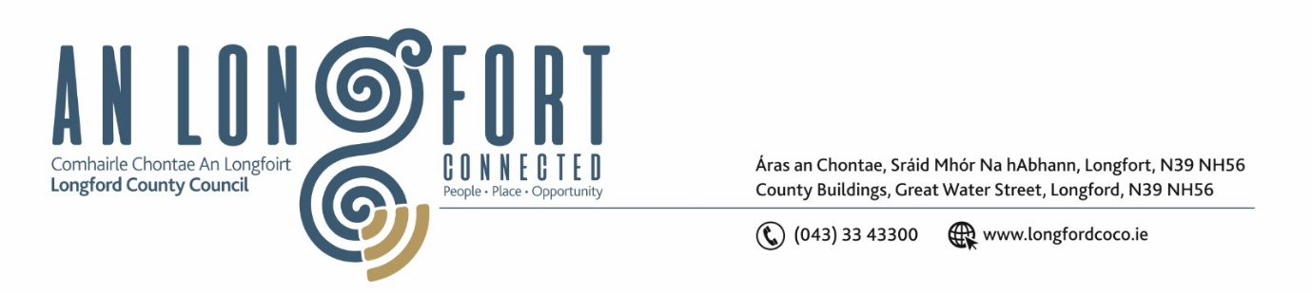

**LONGFORD MUNICIPAL DISTRICT**

***Please note meeting will be held in the Council Chamber, Aras an Chontae and via Microsoft Teams***

**15 November 2023**

**To: Each Member of Longford Municipal District.**

**Dear Member,**

You are requested to attend the Meeting of Longford Municipal District to be held in **the Council Chamber, Aras an Chontae** and **via Microsoft Teams** on **Wednesday 22 November 2023 at 4pm** to transact business, as set out on the agenda hereunder.

**Yours sincerely**,

_______________

**Claire McNabola**

**Meetings Administrator**

**AGENDA**

Prayer before meeting.

**1.** Confirmation of Minutes:

1. Longford Municipal District Meeting held on Wednesday 25 October 2023 – enclosed.
2. Longford Municipal District Committee Meeting held on Wednesday 25 October 2023 – enclosed.
3. Amendments to Minutes of Longford Municipal District Meeting held on 27 September 2023 – enclosed.

**2.** Matters arising from Minutes.

**3.** Declaration of Interest by Members.

**4.** Management Report

**5**. Community Climate Action Fund

**6.** Proposed dates for 2024 MD meetings

**7.** **Notices of Motions, submitted by Councillors, as listed hereunder –**

**Councillor Uruemu Adejinmi**

I call on Longford County Council to make provision for temporary parking permits to be issued to individuals performing jury duty in Longford County Courthouse. Such permits can be provided to the Manager at the Court to be issued to confirmed jurors on the day of their attendance in court.

**Councillor Gerry Hagan**

1. I call on Longford MD Reinstate the road markings at Kiernan’s forge on Ballinalee Rd, i.e. continuous white line and stop signs at crossroads which are in a very dangerous state at moment.
2. I call on Longford MD to alleviate the flooding at junction at Cullyfad crossroads beside church which is very dangerous and even more dangerous when there’s frost.
3. I call on Longford MD to provide disabled car space on Main Street outside Cara All Care Pharmacy, to facilitate elderly people and people with disabilities to access businesses on Main Street.

**8.** **Correspondence**

**(i)** Correspondence received fromUisce Eireann re. Taking in Charge of infrastructure in Cartrun Breac Estate.